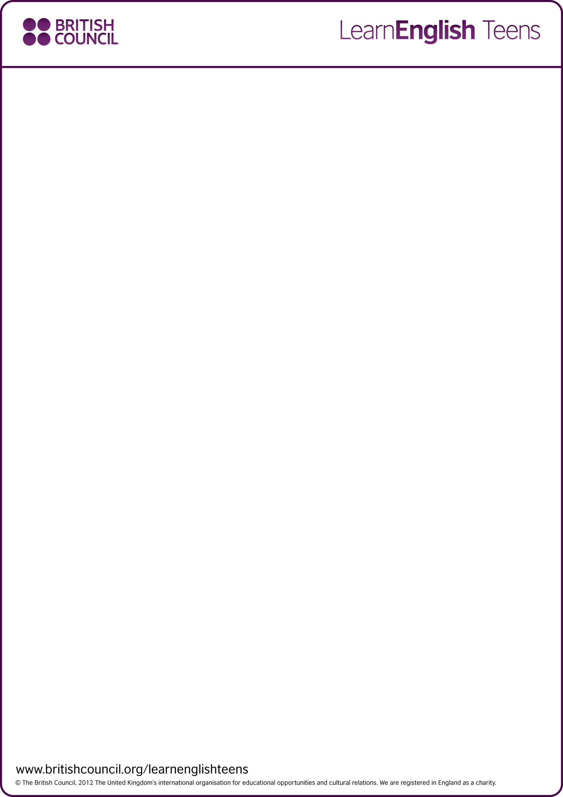
Writing skills practice: A report – exercises
Look at the exam question and report and do the exercises to improve your writing skills.

Preparation
Fill the gaps with the correct word from the box.
 | subheading | information | recommend | aim
1. | You might be asked to write a report when a person in authority needs .
2. | In the first line of the introduction, you should say what the of the report is.
3. | A report should be divided into paragraphs, each with a clear on the left.
4. | At the end of the report, you will probably be asked to what should be done.
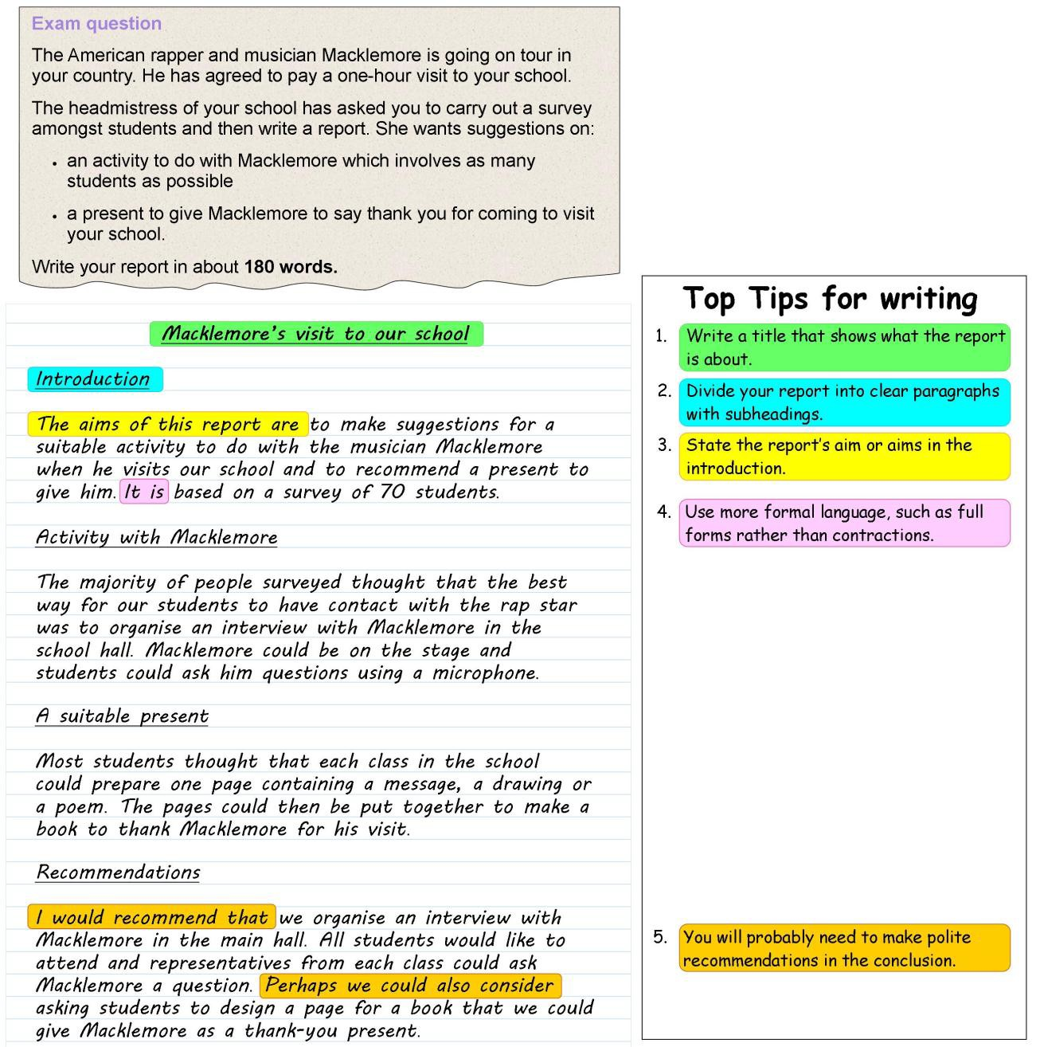

Writing skills practice: A report – exercises

1. Check your understanding: true or false
Circle True or False for these sentences.
1. | The aim of the report is to recommend an activity and present for Macklemore's visit. | True | False
2. | The recommendations are based on the author's opinion. | True | False
3. | Most students agreed that the best activity was an interview. | True | False
4. | A small minority of students liked the idea of making a book as a present. | True | False
5. | The report makes polite suggestions based on the research done. | True | False

2. Check your writing: matching – useful language
Match the words and phrases with their purpose in the box.
 | Summarise what you found out | Conclude by giving your recommendations
 | Say why you are writing the report | Say how you got your information
1. |  | The aim of this report is to ...
2. |  | It is based on a survey of ...
3. |  | The majority/minority of ...
4. |  | I would recommend that we ... / Perhaps we should consider ...

Writing skills practice: A report – exercises

3. Check your writing: gap fill – making recommendations
Complete the second sentence to make recommendations in a more formal way.
1. | We should organise an interview.  Perhaps we could consider .
2. | We should make a book.  I would recommend .
3. | We should prepare questions for the interview.  It would be advisable .
4. | We should invite all students.  I would recommend .
5. | We should use a microphone for the interview.  Perhaps we could consider .
6. | We should choose representatives from each class.  It would be advisable .
7. | We should print the book professionally.  Perhaps we could consider .
8. | We should give students adequate time to prepare their contributions.  I would recommend .

Discussion
Who would you like to come and visit your school?

